# **Vocabulary Reconstruction**

## **Section 1: Task on vocabulary reconstruction**

#### **Research Objectives:**

(1). Verify whether our Gabor Picture (GP) and Gabor Feature (GF) systems can generate high-quality speech on each vocabulary from training and test set.

(2). Evaluate spectrogram accuracy and speech quality on different word categories from the two systems.

(3). Evaluate and compare the reconstructed results from each vocabulary.

#### **Results:**

(1). Results verified Gabor Picture (GP) and Gabor Feature (GF) systems can generate high-quality speech on each vocabulary from training and test set. The Gabor Feature (GF) system outperforms the Gabor Picture (GP) system in overall results.

(2). The speech reconstruction results in word categories show that the Gabor Feature (GF) system outperforms the Gabor Picture (GP) system in word reconstruction in each category. Command, color, digit, and letter categories have better results in spectrogram accuracy, speech quality, speech overall quality and speech intelligibility. Preposition and adverb categories have lower values in spectrogram accuracy, speech quality and speech overall quality.

(3). From the results of each word, we found that the optimal words in each category are BIN (command), RED (color), IN (preposition), PLEASE (adverb), EIGHT (number), S (letter). While the words LAY (command), BLUE (color), WITH (preposition), SOON (adverb), THREE (number), I (letter) performed poorly compared to other words in the same category.

## **Section 2: Dataset (Grid Corpus: speaker 1)**

Table 1 GRID audio-visual corpus vocabulary.

| **Command** | **Color** | **Preposition** | **Letter** | **Digit** | **Adverb** |
| --- | --- | --- | --- | --- | --- |
| bin | blue | at | A-Z | 0-9 | again |
| lay | green | by | minus W |  | now |
| place | red | in |  |  | please |
| Set | white | with |  |  | soon |

## **Section 3: Experimental design**

(1). Select 100 sentence samples from speaker1.

(2) Extract single word from the 100 sentence samples using the time align files.

(3) Get 51 words in 6 categories (as shown in table 2).

(4) Split the sample of each word into training, validation, test set with a ratio of 80%, 10%, 10%.

(5) Train GP and GF systems on each word.

(6) Evaluate the Corr2D and the generated speech on training and test set from each single word.

(7) Evaluate the corr2D and PESQ value on training and test set from each category.

## **Section 4: Evaluation method**

**Corr2D**: measures the accuracy of the reconstructed auditory spectrogram.

**PESQ**: measures the reconstructed speech quality in the time domain.

**Overall Speech Quality:**  evaluates the overall quality (LLR, PESQ and WSS) of a speech.

**STOI:** is a correlation-based metric used to quantify the speech intelligibility.

**Spectrogram / Waveform and Audio / Video**

|  |  |  |  |  |
| --- | --- | --- | --- | --- |
| **Vocabulary reconstruction** | | | | |
| **Category** | **Word** | **Training set** | **Validation set** | **Test set** |
| Command | bin | 80% | 10% | 10% |
| lay | 80% | 10% | 10% |
| place | 80% | 10% | 10% |
| Set | 80% | 10% | 10% |
| Color | blue | 80% | 10% | 10% |
| green | 80% | 10% | 10% |
| red | 80% | 10% | 10% |
| white | 80% | 10% | 10% |
| Preposition | at | 80% | 10% | 10% |
| by | 80% | 10% | 10% |
| in | 80% | 10% | 10% |
| with | 80% | 10% | 10% |
| Adverb | again | 80% | 10% | 10% |
| now | 80% | 10% | 10% |
| please | 80% | 10% | 10% |
| soon | 80% | 10% | 10% |
| Digit | 0 | 80% | 10% | 10% |
| 1 | 80% | 10% | 10% |
| 2 | 80% | 10% | 10% |
| 3 | 80% | 10% | 10% |
| 4 | 80% | 10% | 10% |
| 5 | 80% | 10% | 10% |
| 6 | 80% | 10% | 10% |
| 7 | 80% | 10% | 10% |
| 8 | 80% | 10% | 10% |
| 9 | 80% | 10% | 10% |
| Letter | A | 80% | 10% | 10% |
| B | 80% | 10% | 10% |
| C | 80% | 10% | 10% |
| D | 80% | 10% | 10% |
| E | 80% | 10% | 10% |
| F | 80% | 10% | 10% |
| G | 80% | 10% | 10% |
| H | 80% | 10% | 10% |
| I | 80% | 10% | 10% |
| J | 80% | 10% | 10% |
| K | 80% | 10% | 10% |
| L | 80% | 10% | 10% |
| M | 80% | 10% | 10% |
| N | 80% | 10% | 10% |
| O | 80% | 10% | 10% |
| P | 80% | 10% | 10% |
| Q | 80% | 10% | 10% |
| R | 80% | 10% | 10% |
| S | 80% | 10% | 10% |
| T | 80% | 10% | 10% |
| U | 80% | 10% | 10% |
| V | 80% | 10% | 10% |
| X | 80% | 10% | 10% |
| Y | 80% | 10% | 10% |
| Z | 80% | 10% | 10% |

## **Section 5: Demo Result**

*(Double click the follow picture to play the video)*



## **Section 6: Result analysis**

**6.1 Average results on GF and GP system**

The average results and average training results show the Gabor Feature (GF) system outperforms the Gabor Picture (GP) system in the spectrogram accuracy, speech quality, speech overall quality and speech intelligibility.

The average testing results show the Gabor Feature (GF) system outperforms the Gabor Picture (GP) system in the reconstructed spectrogram accuracy, overall speech quality. The Gabor Picture (GP) system outperforms the Gabor Feature (GF) system in speech quality and speech intelligibility.

|  |  |
| --- | --- |
|  |  |
| |  |  |  |  |  | | --- | --- | --- | --- | --- | |  | Corr2D | PESQ | OO | STOI | | GF_Train | 0.807 | 1.217 | 0.326 | 0.475 | | GP_Train | 0.737 | 0.908 | 0.316 | 0.461 | | GF_Test | 0.67 | 0.87 | 0.415 | 0.391 | | GP_Test | 0.618 | 0.907 | 0.291 | 0.402 | | **GF_Avg** | **0.7796** | **1.1476** | **0.3438** | **0.4582** | | **GP_Avg** | **0.7132** | **0.9078** | **0.311** | **0.4492** | |

**6.2 Results on word categories**

The word reconstruction results in categories show that the Gabor Feature (GF) system outperforms the Gabor Picture (GP) system in word reconstruction in each category. For both systems, the reconstruction results from training set are better than those on test set.

Command, color, digit, and letter categories have better results in spectrogram accuracy, speech quality, speech overall quality and speech intelligibility. Among them, the letter class has the best results in spectrogram accuracy and speech intelligibility; the command class has the best speech quality results; the digit class has the best speech overall quality results.

Preposition and adverb categories have lower values in spectrogram accuracy, speech quality and speech overall quality. Among them, the preposition class has the lowest spectrogram accuracy, but good speech intelligibility results; the Adverb class has the lowest speech quality, speech overall quality and speech intelligibility results.

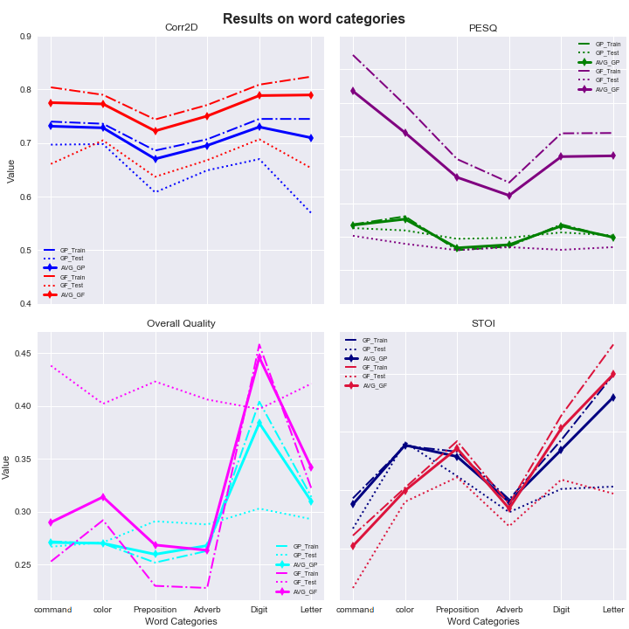

**6.3 Results on each vocabulary**

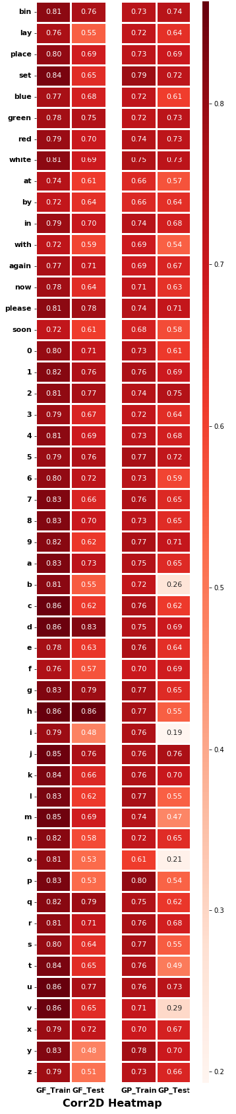 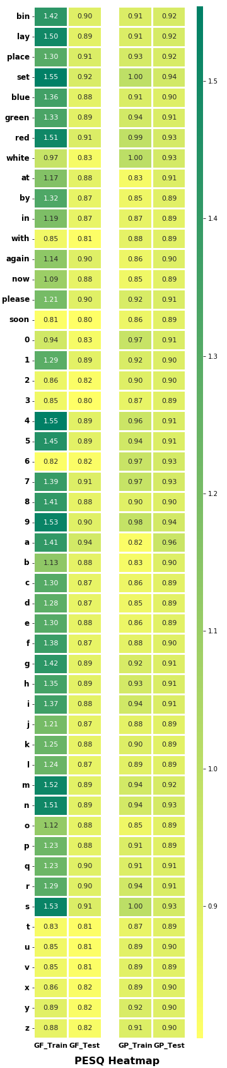 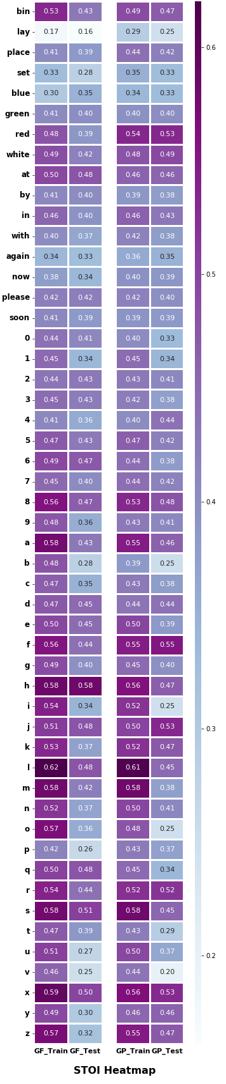

## **Section 7: Reconstructed spectrogram**

|  |  |  |  |  |  |  |  |  |
| --- | --- | --- | --- | --- | --- | --- | --- | --- |
| **Reconstructed spectrogram** | | | | | | | | |
|  |  | TRAINING SET | | |  | TEST SET | | |
|  |  | GP-SYS | GF-SYS | ORIGINAL | GP-SYS | GF-SYS | ORIGINAL |
| Command | bin |  |  |  |  |  |  |
| lay |  |  |  |  |  |  |
| place |  |  |  |  |  |  |
| Set |  |  |  |  |  |  |
|  | | | | |  | | |
| Color | blue |  |  |  |  |  |  |
| green |  |  |  |  |  |  |
| red |  |  |  |  |  |  |
| white |  |  |  |  |  |  |
|  | | | | |  | | |
| Preposition | at |  |  |  |  |  |  |
| by |  |  |  |  |  |  |
| in |  |  |  |  |  |  |
| with |  |  |  |  |  |  |
|  | | | | |  | | |
| Adverb | again |  |  |  |  |  |  |
| now |  |  |  |  |  |  |
| please |  |  |  |  |  |  |
| soon |  |  |  |  |  |  |
|  | | | | |  | | |
| Digit | 0 |  |  |  |  |  |  |
| 1 |  |  |  |  |  |  |
| 2 |  |  |  |  |  |  |
| 3 |  |  |  |  |  |  |
| 4 |  |  |  |  |  |  |
| 5 |  |  |  |  |  |  |
| 6 |  |  |  |  |  |  |
| 7 |  |  |  |  |  |  |
| 8 |  |  |  |  |  |  |
| 9 |  |  |  |  |  |  |
|  | | | | |  | | |
| Letter | A |  |  |  |  |  |  |
| B |  |  |  |  |  |  |
| C |  |  |  |  |  |  |
| D |  |  |  |  |  |  |
| E |  |  |  |  |  |  |
| F |  |  |  |  |  |  |
| G |  |  |  |  |  |  |
| H |  |  |  |  |  |  |
| I |  |  |  |  |  |  |
| J |  |  |  |  |  |  |
| K |  |  |  |  |  |  |
| L |  |  |  |  |  |  |
| M |  |  |  |  |  |  |
| N |  |  |  |  |  |  |
| O |  |  |  |  |  |  |
| P |  |  |  |  |  |  |
| Q |  |  |  |  |  |  |
| R |  |  |  |  |  |  |
| S |  |  |  |  |  |  |
| T |  |  |  |  |  |  |
| U |  |  |  |  |  |  |
| V |  |  |  |  |  |  |
| X |  |  |  |  |  |  |
| Y |  |  |  |  |  |  |
| Z |  |  |  |  |  |  |

## **Section 8: Reconstructed waveform**

|  |  |  |  |  |  |  |  |  |
| --- | --- | --- | --- | --- | --- | --- | --- | --- |
| **Reconstructed waveform** | | | | | | | | |
|  |  | **TRAINING SET** | | |  | **TEST SET** | | |
|  |  | **GP-SYS** | **GF-SYS** | **ORIGINAL** | **GP-SYS** | **GF-SYS** | **ORIGINAL** |
| **Comma**  **nd** | **Bin** |  |  |  |  |  |  |
| **lay** |  |  |  |  |  |  |
| **place** |  |  |  |  |  |  |
| **Set** |  |  |  |  |  |  |
|  | | | | |  | | |
| **Color** | **blue** |  |  |  |  |  |  |
| **green** |  |  |  |  |  |  |
| **red** |  |  |  |  |  |  |
| **white** |  |  |  |  |  |  |
|  | | | | |  | | |
| **Preposition** | **at** |  |  |  |  |  |  |
| **by** |  |  |  |  |  |  |
| **in** |  |  |  |  |  |  |
| **with** |  |  |  |  |  |  |
|  | | | | |  | | |
| **Adverb** | **again** |  |  |  |  |  |  |
| **now** |  |  |  |  |  |  |
| **please** |  |  |  |  |  |  |
| **soon** |  |  |  |  |  |  |
|  | | | | |  | | |
| **Digit** | **0** |  |  |  |  |  |  |
| **1** |  |  |  |  |  |  |
| **2** |  |  |  |  |  |  |
| **3** |  |  |  |  |  |  |
| **4** |  |  |  |  |  |  |
| **5** |  |  |  |  |  |  |
| **6** |  |  |  |  |  |  |
| **7** |  |  |  |  |  |  |
| **8** |  |  |  |  |  |  |
| **9** |  |  |  |  |  |  |
|  | | | | |  | | |
| **Letter** | **A** |  |  |  |  |  |  |
| **B** |  |  |  |  |  |  |
| **C** |  |  |  |  |  |  |
| **D** |  |  |  |  |  |  |
| **E** |  |  |  |  |  |  |
| **F** |  |  |  |  |  |  |
| **G** |  |  |  |  |  |  |
| **H** |  |  |  |  |  |  |
| **I** |  |  |  |  |  |  |
| **J** |  |  |  |  |  |  |
| **K** |  |  |  |  |  |  |
| **L** |  |  |  |  |  |  |
| **M** |  |  |  |  |  |  |
| **N** |  |  |  |  |  |  |
| **O** |  |  |  |  |  |  |
| **P** |  |  |  |  |  |  |
| **Q** |  |  |  |  |  |  |
| **R** |  |  |  |  |  |  |
| **S** |  |  |  |  |  |  |
| **T** |  |  |  |  |  |  |
| **U** |  |  |  |  |  |  |
| **V** |  |  |  |  |  |  |
| **X** |  |  |  |  |  |  |
| **Y** |  |  |  |  |  |  |
| **Z** |  |  |  |  |  |  |

## **Section 9: Reconstructed speech**

|  |  |  |  |  |  |  |  |  |
| --- | --- | --- | --- | --- | --- | --- | --- | --- |
| **Reconstructed speech** | | | | | | | | |
|  |  | TRAINING SET | | |  | TEST SET | | |
|  |  | GP-SYS | GF-SYS | ORIGINAL | GP-SYS | GF-SYS | ORIGINAL |
| Command | bin |  |  |  |  |  |  |
| lay |  |  |  |  |  |  |
| place |  |  |  |  |  |  |
| Set |  |  |  |  |  |  |
|  | | | | |  | | |
| Color | blue |  |  |  |  |  |  |
| green |  |  |  |  |  |  |
| red |  |  |  |  |  |  |
| white |  |  |  |  |  |  |
|  | | | | |  | | |
| Preposition | at |  |  |  |  |  |  |
| by |  |  |  |  |  |  |
| in |  |  |  |  |  |  |
| with |  |  |  |  |  |  |
|  | | | | |  | | |
| Adverb | again |  |  |  |  |  |  |
| now |  |  |  |  |  |  |
| please |  |  |  |  |  |  |
| soon |  |  |  |  |  |  |
|  | | | | |  | | |
| Digit | 0 |  |  |  |  |  |  |
| 1 |  |  |  |  |  |  |
| 2 |  |  |  |  |  |  |
| 3 |  |  |  |  |  |  |
| 4 |  |  |  |  |  |  |
| 5 |  |  |  |  |  |  |
| 6 |  |  |  |  |  |  |
| 7 |  |  |  |  |  |  |
| 8 |  |  |  |  |  |  |
| 9 |  |  |  |  |  |  |
|  | | | | |  | | |
| Letter | A |  |  |  |  |  |  |
| B |  |  |  |  |  |  |
| C |  |  |  |  |  |  |
| D |  |  |  |  |  |  |
| E |  |  |  |  |  |  |
| F |  |  |  |  |  |  |
| G |  |  |  |  |  |  |
| H |  |  |  |  |  |  |
| I |  |  |  |  |  |  |
| J |  |  |  |  |  |  |
| K |  |  |  |  |  |  |
| L |  |  |  |  |  |  |
| M |  |  |  |  |  |  |
| N |  |  |  |  |  |  |
| O |  |  |  |  |  |  |
| P |  |  |  |  |  |  |
| Q |  |  |  |  |  |  |
| R |  |  |  |  |  |  |
| S |  |  |  |  |  |  |
| T |  |  |  |  |  |  |
| U |  |  |  |  |  |  |
| V |  |  |  |  |  |  |
| X |  |  |  |  |  |  |
| Y |  |  |  |  |  |  |
| Z |  |  |  |  |  |  |

## **Section 10: Reconstructed clear speech (clear audio)**

|  |  |  |  |  |  |  |  |  |
| --- | --- | --- | --- | --- | --- | --- | --- | --- |
| **Reconstructed clear speech** | | | | | | | | |
|  |  | TRAINING SET | | |  | TEST SET | | |
|  |  | GP-SYS | GF-SYS | ORIGINAL | GP-SYS | GF-SYS | ORIGINAL |
| Command | bin |  |  |  |  |  |  |
| lay |  |  |  |  |  |  |
| place |  |  |  |  |  |  |
| Set |  |  |  |  |  |  |
|  | | | | |  | | |
| Color | blue |  |  |  |  |  |  |
| green |  |  |  |  |  |  |
| red |  |  |  |  |  |  |
| white |  |  |  |  |  |  |
|  | | | | |  | | |
| Preposition | at |  |  |  |  |  |  |
| by |  |  |  |  |  |  |
| in |  |  |  |  |  |  |
| with |  |  |  |  |  |  |
|  | | | | |  | | |
| Adverb | again |  |  |  |  |  |  |
| now |  |  |  |  |  |  |
| please |  |  |  |  |  |  |
| soon |  |  |  |  |  |  |
|  | | | | |  | | |
| Digit | 0 |  |  |  |  |  |  |
| 1 |  |  |  |  |  |  |
| 2 |  |  |  |  |  |  |
| 3 |  |  |  |  |  |  |
| 4 |  |  |  |  |  |  |
| 5 |  |  |  |  |  |  |
| 6 |  |  |  |  |  |  |
| 7 |  |  |  |  |  |  |
| 8 |  |  |  |  |  |  |
| 9 |  |  |  |  |  |  |
|  | | | | |  | | |
| Letter | A |  |  |  |  |  |  |
| B |  |  |  |  |  |  |
| C |  |  |  |  |  |  |
| D |  |  |  |  |  |  |
| E |  |  |  |  |  |  |
| F |  |  |  |  |  |  |
| G |  |  |  |  |  |  |
| H |  |  |  |  |  |  |
| I |  |  |  |  |  |  |
| J |  |  |  |  |  |  |
| K |  |  |  |  |  |  |
| L |  |  |  |  |  |  |
| M |  |  |  |  |  |  |
| N |  |  |  |  |  |  |
| O |  |  |  |  |  |  |
| P |  |  |  |  |  |  |
| Q |  |  |  |  |  |  |
| R |  |  |  |  |  |  |
| S |  |  |  |  |  |  |
| T |  |  |  |  |  |  |
| U |  |  |  |  |  |  |
| V |  |  |  |  |  |  |
| X |  |  |  |  |  |  |
| Y |  |  |  |  |  |  |
| Z |  |  |  |  |  |  |